Computer Graphics Programming -- Practical Class

Week-1
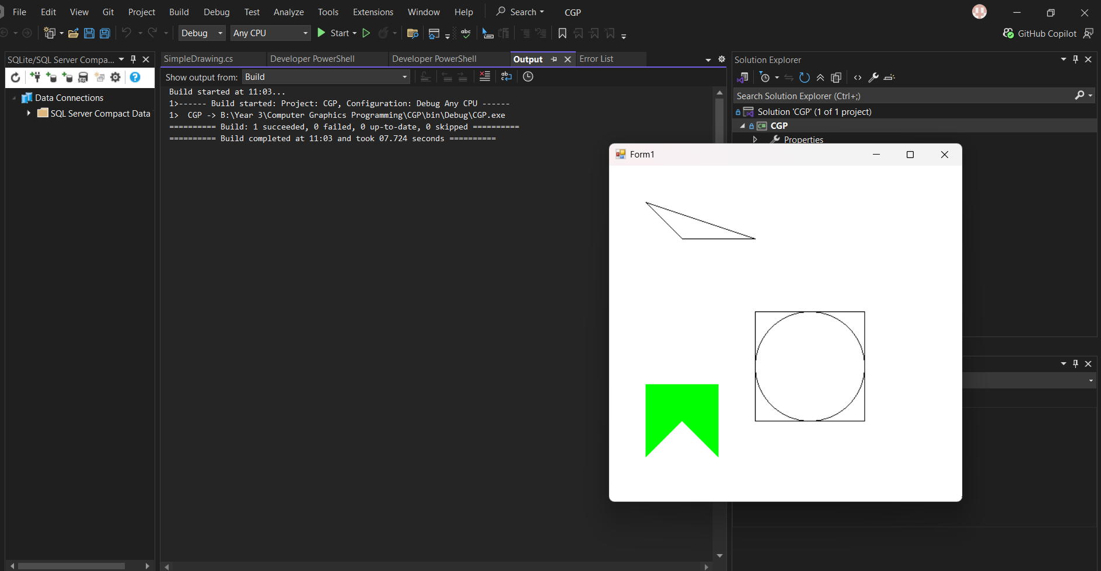
Figure 1 Q1 CircleInSquare
I have create a project in vs community using C# Windows Forms App (.NET Framework).
And rename the form1.cs to SimpleDrawing.cs. Pasted the code from the canvas.
Solved the Q1 Circle in Square editing Co-ordinates of a circle to fit into the rectangle.

